12.What is meant by supervised learning, unsupervised learning and learning by demonstration? Give an example for each learning paradigm.

第八章

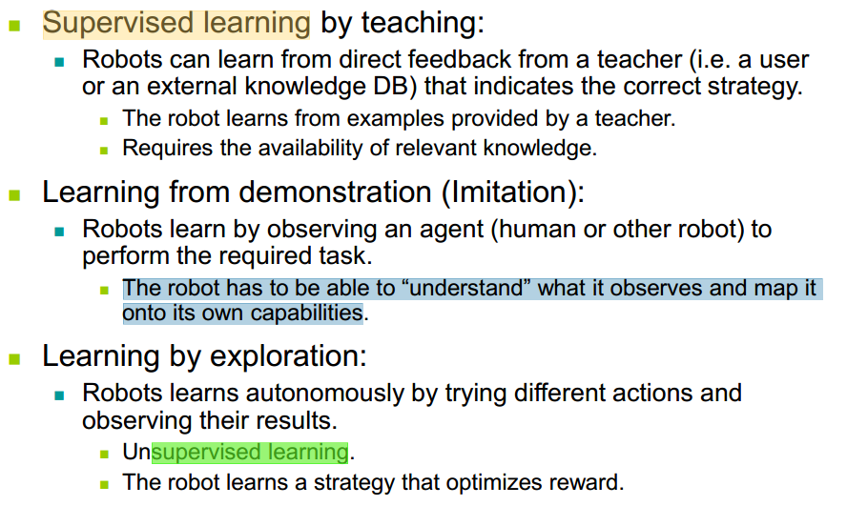

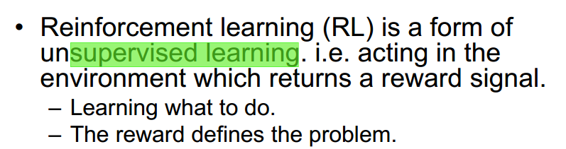

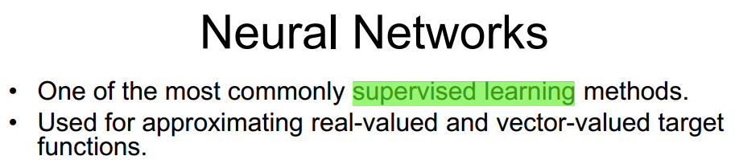

13.Briefly explain the difference between reacting control systems and deliberative control systems

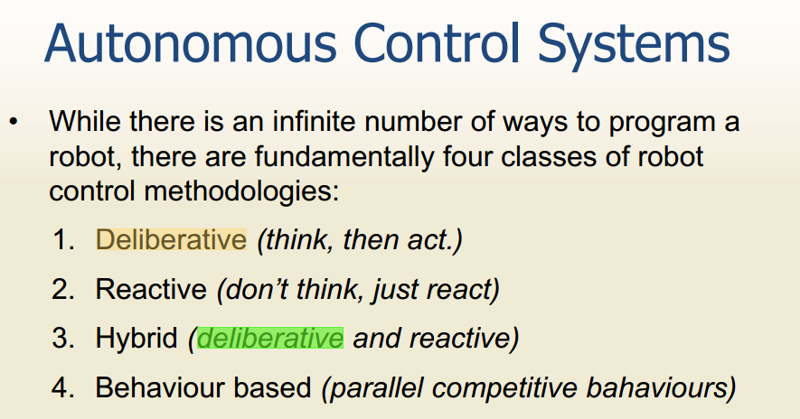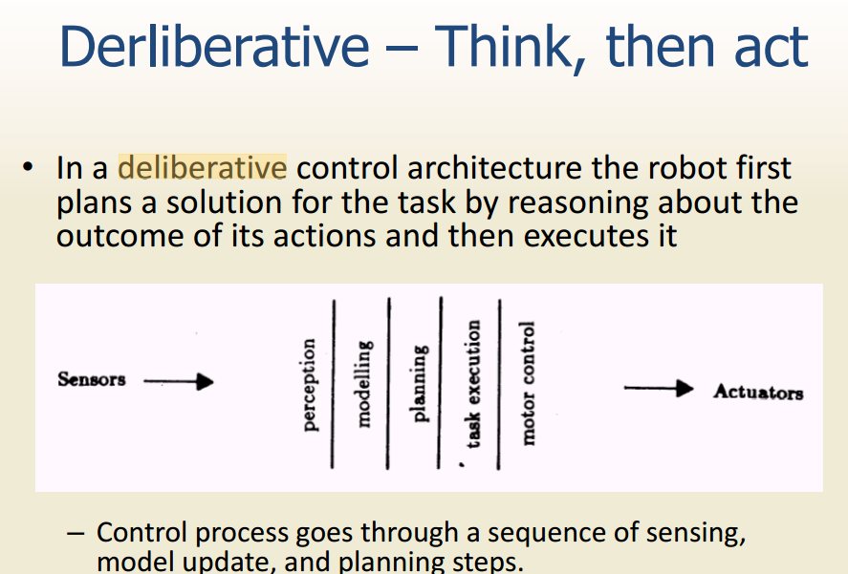

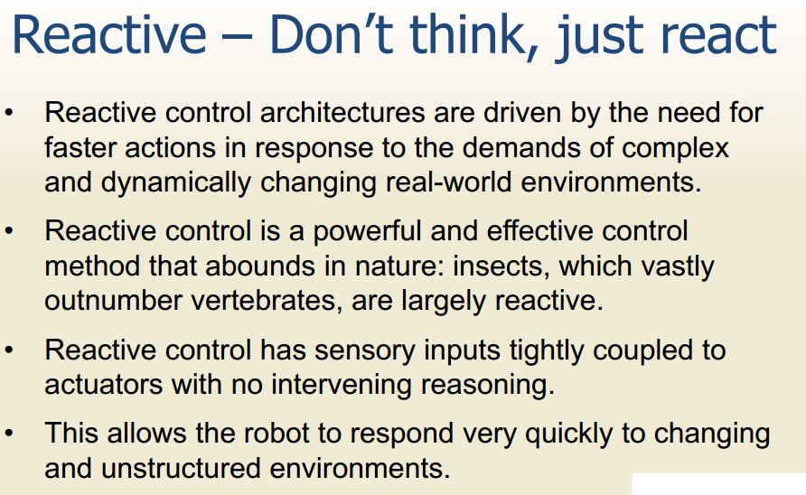 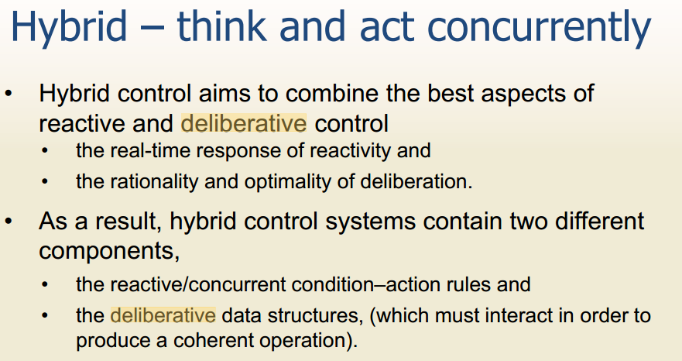

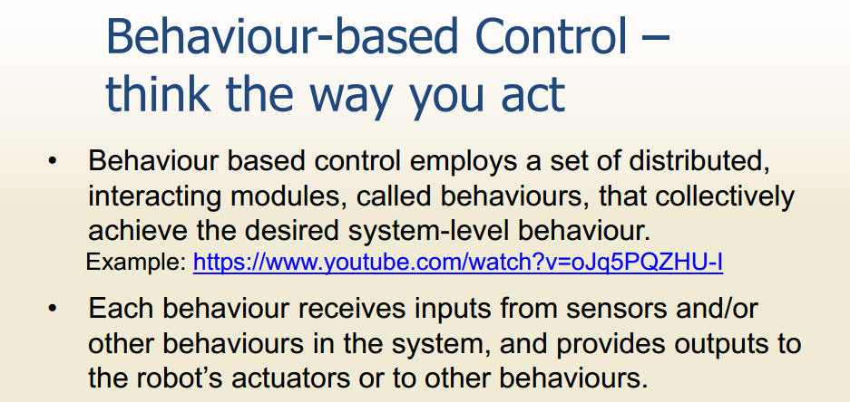

(14) In terms of localisation and mapping explain how a mobile robot could navigation the

environment with the use of:

(a) continuous landmarks

(b) non continuous landmarks (15) What is the credit assignment problem with respect to mobile robots. You may use a

diagram to explain your answer

(16) Name 4 sensors discussed in this course and discuss their function and limitations?

Sonar, rador, Infrared Sensors, Camera Sensor

(17) What is an occupancy grid? How might you devise an occupancy grid that can cope with odometry errors?

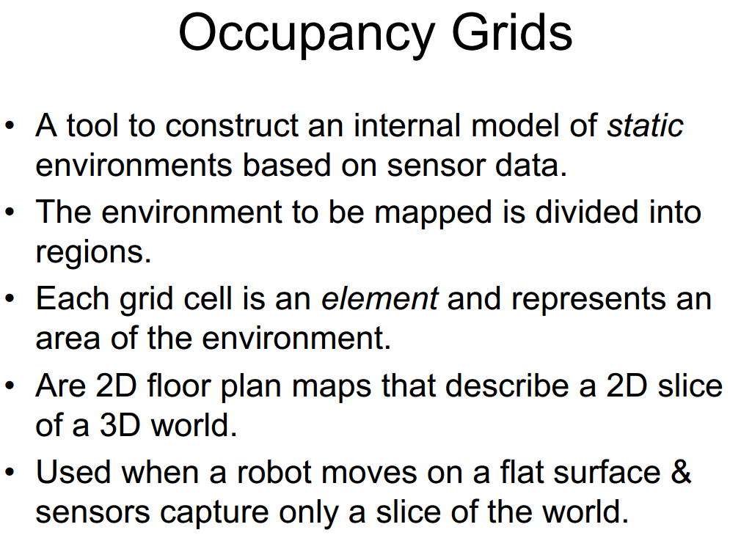

(18) In terms of sensing and control briefly explain how you might devise a robot vacuum

cleaner that can find and dock with its charging bay?

传感和控制方面如何设计一个机器人：涉及478章内容

(19) What is sensor fusion? Give an example of sensor fusion and explain how the example

given works.

第五章 传感器融合，但是没有例子

(20) Why might a simulator be used to assist with the development of a mobile robot control

system? What special considerations need to be taken into account when devising a

mobile robot simulator.